g  WEEK 1 | Shazam Division (Ages 13-16 years old)
g  WEEK 1 | MONDAY | TUESDAY | WEDNESDAY | THURSDAY | FRIDAY
g  WEEK 1 | July 7    Air Trampoline | July 8    Swim | July 9  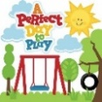  Park Activities | July 10    Swim | July 11    Adventure Park
WEEK 2 | July 14    Tiki Action Park | July 15  Swim | July 16    Bowling | July 17  Swim | July 18  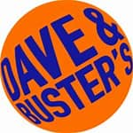  Dave & Buster
WEEK 3 | July 21    Q-Zar | July 22  Swim | July 23  Park Activities | July 24    Swim | July 25    Adventure Land
WEEK 4 | July 28  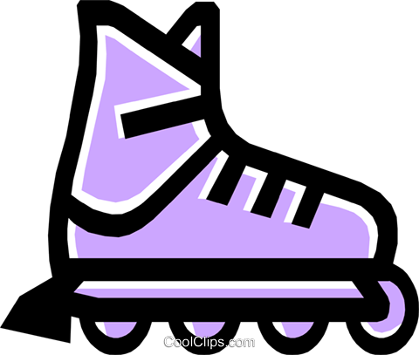  Roller Skating | July 29  Swim | July 30  Bowling | July 31  Swim | Aug 1    Movie Theater
WEEK 5 | Aug 4  Dave & Buster | Aug 5  Swim | Aug 6  Park Activities | August 7  Swim | Aug 8  Park Activities
WEEK 6 | Aug 11  Movie Theater | Aug 12  Swim | Aug 13  Bowling | Aug 14  Swim | Aug 15  Roller Skating
WEEK 7 |   Aug 18  Tiki Action Park | Aug 19  Swim | Aug 20  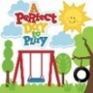  Park Activities | Aug 21  Swim | Aug 22  Park Activities
WEEK 8 | Aug 25  Movie Theater | Aug 26  Swim | Aug 27  Bowling | Aug 28    Swim | Aug 29    Adventure Land

